# Lab Streams 1: Kafka

## Objectives

In this lab you will create a Kafka topic, and run both a consumer and producer for that topic

## Instructions

### Step 1 Start up the Zookeeper

1. Kafka has been installed on your lab machine. For this lab we will be executing CLI commands to use Kafka
2. Graphical user interface, table

   Description automatically generatedKafka is located as shown below
3. The commands we will be using will be in the windows directory
4. Open a command window, go to the Kafka directory and enter the command:

.\bin\windows\zookeeper-server-start.bat .\config\zookeeper.properties

1. Do not close this window or the zookeeper will shut down
2. You should see something like this:

### Step 2: Start a Kafka broker

1. Open a new command window and go to the c:\kafka directory
2. Enter the command

.\bin\windows\kafka-server-start.bat .\config\server.properties

1. Do not close this window or the Kafka broker will shut down
2. You should see something like this:

### Step 3: Create a Topic

1. Open yet another command window, this is the third one.
2. Go to the Kafka directory at C:\kafka
3. Enter the following command.

bin\windows\kafka-topics.bat --create --bootstrap-server localhost:9092 --topic lab1

1. Text

   Description automatically generatedThere was a previous test topic created to test the installation. Below we see the result of creating a topic and listing all of the topics

### Step 4: Create a producer

1. And yes, yet another command window.
2. Go the C:\kafka directory and enter the command:

.\bin\windows\kafka-console-producer.bat --bootstrap-server localhost:9092 --topic lab1

1. You should see something like this as you type messages into the producer

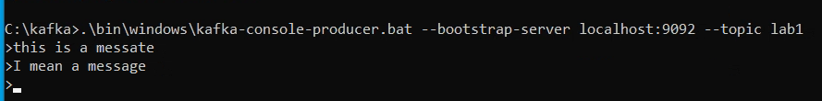

### Step 5: Create a consumer

1. Open another command window, go the C:\kafka directory and enter the following command

.\bin\windows\kafka-console-consumer.bat --bootstrap-server localhost:9092 --topic test --from-beginning

1. A screenshot of a computer

   Description automatically generated with medium confidenceYou should see something like this
2. Experiment with typing message in the producer and see them being picked up by the consumer

### Step 6: Shutdown

To shut down kafka, we normally used the shutdown commands but since we are doing a little toy streaming service, just close all of the command windows.